Driven Racing Oil™ BR20 Break-In Oil
Huntersville, NC – Formulated for engines requiring low viscosity oils, Driven Racing Oil™ BR20 Conventional 5W-20 Break-In Oil offers unmatched protection for internal components.
BR20 promotes proper surface mating during the critical break-in process and chemically assists with piston ring sealing, thanks to a proprietary anti-wear formulation that doesn’t rely on conventional friction modifiers. It also features a low detergent level that allows the “fast burn” ZDDP additive to adhere directly to all ferrous metal wear surfaces for maximum scuffing protection.
Driven engineered BR20 for use in engines that call for the use of 0W-16, 0W-20 and 5W-20 viscosity oils, as well as for overhead cam engines with tight bearing clearances. It is good for dyno testing, one night of racing or up to 400 miles on the street, with no ZDDP or break-in additives required. Viscosity of typical of 5W-20.
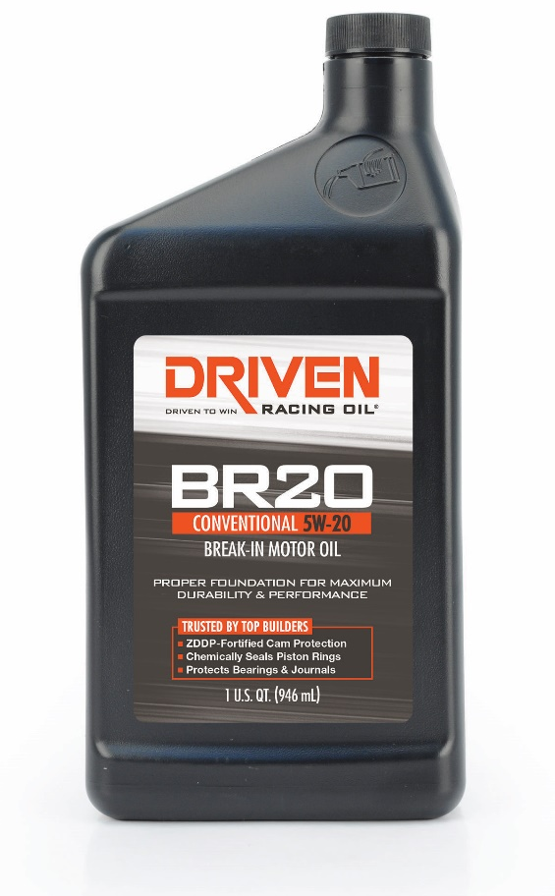
Part Numbers: #04346(1 qt.) Price: $9.49
About Driven Racing Oil™
Driven Racing Oil™ utilizes cutting-edge lubricant technology and on-track research for maximum performance gains from all of its product offerings. Competition drives innovation, and Joe Gibbs Racing originally developed the Driven brand of oils to advance engine and driveline performance on the racetrack. From full-synthetic race oils to engine break-in oils and cleaners, Driven offers a wide range of race and street products that deliver performance, protection and value.

